**Most of the software for a big web application lives in either the “Web Tier” or the “Business Tire”**

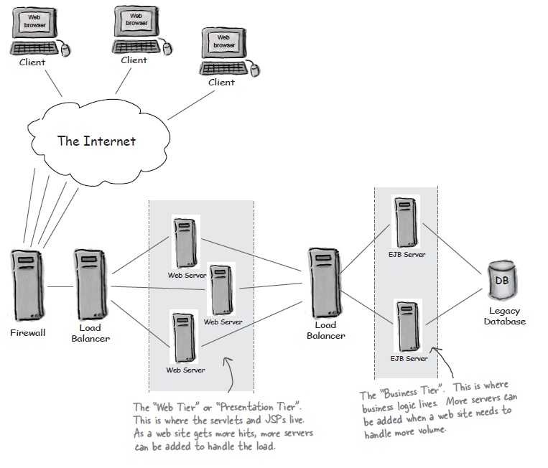

As we’ve seen, it’s very common for a web application to be made of many different kinds of software components. The web tier frequently contains HTML pages, JSPs, servlets, controllers, model components, images, and so on. The business tier can contain **EJBs,** legacy applications, lookup registers, and in most cases database drivers, and databases.

**A software design pattern is “a repeatable solution for a commonly-occurring software problem.**